THE COMPLETE
CLAUDE BEGINNER'S GUIDE

5 Days. Chat → Cowork → Code.

─────────────────────────

A step-by-step roadmap that takes you from complete beginner
to running real automations — in five days.

[ ] 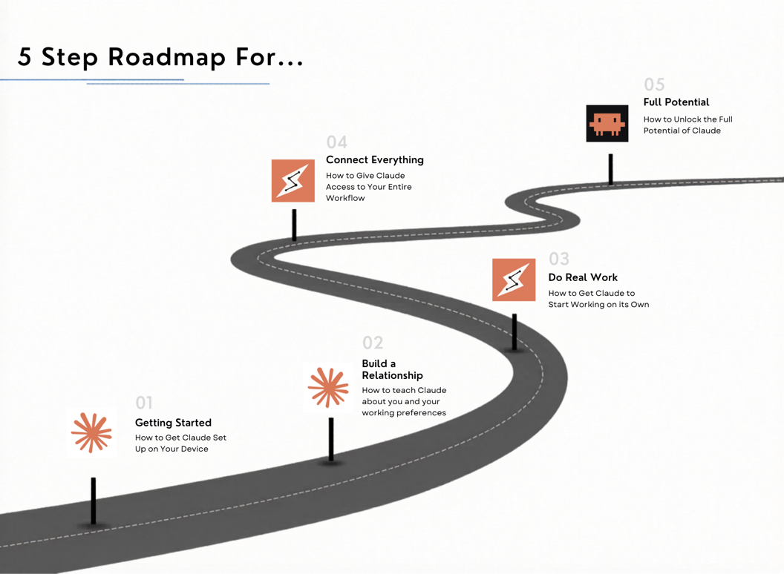

Welcome

Most people use Claude like a fancy search engine. They type a question, get an answer, and close the tab. This guide is going to show you a completely different way to use it.

Over five days, you're going to go from setting up the app for the first time to running real automations that do work for you while you're not at your desk. Each day builds on the last. Each step is designed to be completed in under 30 minutes.

By the end of Day 5, Claude won't feel like a chatbot. It'll feel like a coworker who already knows you, has access to your files, and never needs to be asked the same thing twice.

How this guide works: Days 1–2 are Chat (easy). Days 3–4 are Cowork (medium). Day 5 is Claude Code (advanced). Start simple. Build up.

Your 5-Day Roadmap at a Glance
Day | Focus | What You'll Do
Day 1 | Get Set Up | Download the app, create your 4 project folders
Day 2 | Teach Claude Who You Are | Create your about-me.md and AI-style.md files
Day 3 | Do Real Work Together | Upload files, start a real Project with pinned context
Day 4 | Connect Your Tools | Link Google, Notion, Slack, and more via MCP
Day 5 | Build Your First Automation | Install Claude Code, automate your first real task

DAY 1  CHAT | Get Set Up  Download, organize, and build your foundation

Step 1 — Download the Desktop App
Open your browser and go to claude.ai. In the top navigation, you'll find a download option for the desktop app. Download it for Mac or Windows and install it like any other application.

Why does this matter? The browser version works, but the desktop app is faster, keeps Claude separate from your other tabs, and makes it feel like a real tool in your workflow rather than just another website you keep open.

Step 2 — Create Your 4 Starter Folders
Once you're inside the app, look for the Projects section in the left sidebar. This is where you'll create four folders that will become the foundation of your entire Claude setup.
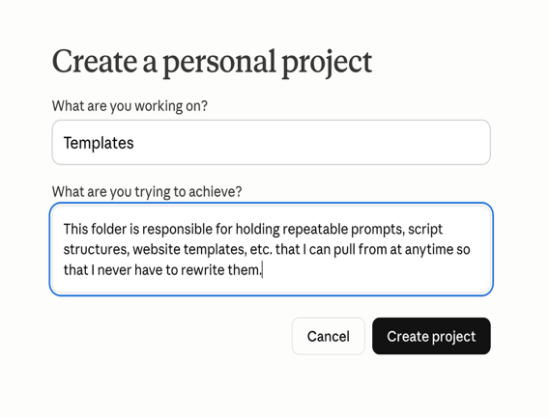
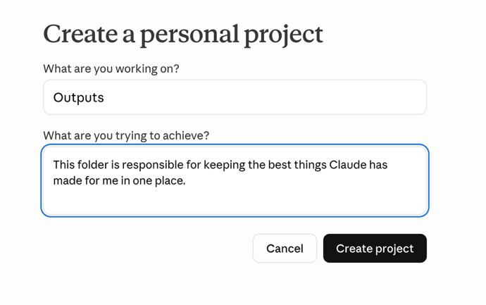

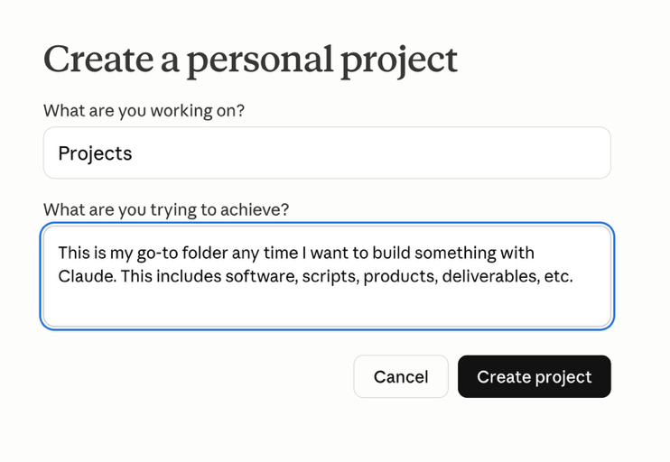
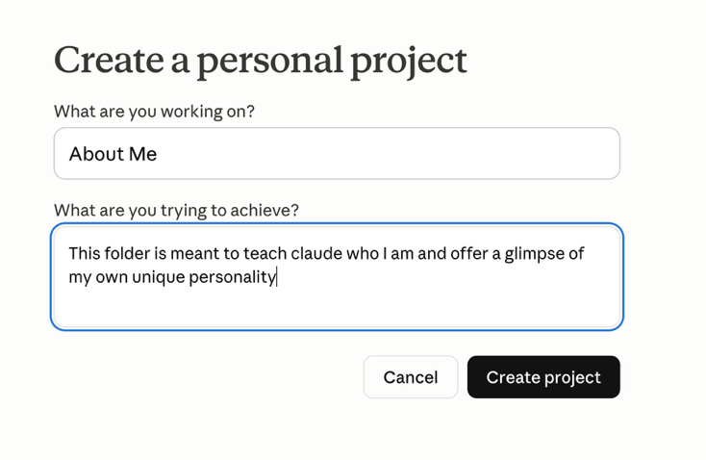

Here are the four folders to create and exactly what each one is for:

- About Me — Tells Claude who you are so it never has to guess.
- Projects — Holds the context for everything you're actively working on.
- Templates — Stores your best prompts so you never have to rewrite them.
- Resources — Stores the reference material and docs Claude needs to do your work accurately.

Why folders? Claude has no memory between conversations by default. These folders let you pin context — files, instructions, and background — that carries over automatically every time you open a new chat inside that project.

DAY 2  CHAT | Teach Claude Who You Are  Create the files that make Claude actually know you
Step 1 — Create Your about-me.md File
Claude starts every conversation knowing nothing about you. To fix that, you're going to create a simple text file called about-me.md that you'll drop into every project folder.

This file covers who you are, what you do, and how you work. When Claude has this context, it stops giving generic answers and starts giving answers calibrated to your actual situation. Think of it as a hiring packet you hand Claude before it starts working for you.

Included in this guide: Your about-me.md template is included as a separate document. Fill in the blanks and paste it into your About Me project folder.

Step 2 — Create Your AI-Style File
The second file tells Claude how to communicate with you. Without it, Claude defaults to a generic assistant voice — overly formal, bullet-heavy, full of filler phrases like 'great question' and 'certainly.'

Your AI-style file fixes that. It tells Claude your preferred tone, how to format responses, when to ask clarifying questions before acting, and what habits to avoid entirely.

Included in this guide: Your AI-style template is included as a separate document. Customize it and pin it to every project you create.

Bonus: Your First Prompt Technique
Before moving to Day 3, learn this one technique that immediately improves every response you get from Claude:

Start any complex request with:

Before you answer, ask me any clarifying questions you need to give me the best possible response.

This forces Claude to surface its assumptions before it produces output. Instead of guessing what you mean and filling gaps with generic thinking, it asks you first. The result is dramatically better than anything it would have produced on its own.

DAY 3  COWORK | Do Real Work Together  Use Claude on real documents and real projects

Step 1 — Upload a Real Document
Claude can read PDFs, Word docs, spreadsheets, and plain text files. You upload them directly into the chat by clicking the attachment icon, and then you just tell Claude what to do with them.

Here are real examples of what professionals use this for:

- Upload meeting notes → ask Claude to extract every action item with the owner and deadline
- Upload a contract → ask Claude to flag any clauses that seem unusual or one-sided
- Upload a competitor's content → ask Claude to identify the angle, the audience, and the offer
- Upload a spreadsheet → ask Claude to summarize the trends and highlight anything worth your attention

Step 2 — Set Up a Real Project
Now you're going to make everything you've built so far work together. Open one of the project folders you created on Day 1 and do three things:

- Pin your about-me.md to the project instructions
- Pin your AI-style file to the project instructions
- Start a new conversation inside that project

From this point forward, every conversation inside that project automatically inherits your identity files. Claude already knows who you are, how you like to communicate, and what you're working on — without you saying a word.

This is the shift: Claude stops feeling like a search engine and starts feeling like a coworker who already knows your situation. Because at that point, it does.

DAY 4  COWORK | Connect Your Tools  Give Claude access to your entire workflow

What Are MCP Connectors?
MCP stands for Model Context Protocol. It's the system that lets Claude talk directly to other apps — your email, your calendar, your documents, your project management tools.

Without MCP, Claude only knows what's inside the Claude app. With MCP, Claude can read your actual emails, pull from your real Google Drive, draft into your inbox, and create calendar events. You stop copying and pasting between apps. Everything happens from one place.

Step 1 — Connect Your Core Tools
Click on the connectors section inside Claude settings. You'll see a directory of available apps. Start with the tools you already use every day:

- Google Drive — Claude can read and reference your real documents
- Gmail — Claude can draft emails directly into your inbox
- Google Calendar — Claude can check your schedule and create events

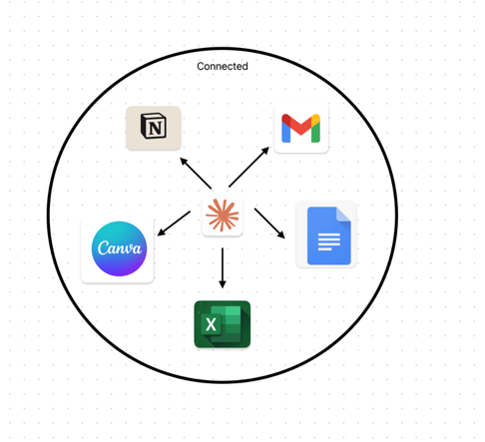

Step 2 — Explore What's Available
There are hundreds of connectors available — Notion, Slack, Asana, HubSpot, Linear, and more. The right ones depend on your workflow. Browse the directory and connect anything you use regularly.

The goal for today: Connect at least one tool and ask Claude to do something real with it. Draft an email. Pull a document. Create a calendar event. Feel the difference between Claude-as-chatbot and Claude-as-operating-layer.

DAY 5  CODE | Build Your First Automation  Make Claude work while you sleep

What Is Claude Code?
Claude Code is a separate tab inside the Claude desktop app. It gives Claude direct access to your computer — your files, your folders, your applications. This is where Claude stops answering questions and starts taking actions.

The key thing to understand is this: you do not need to know how to code. You describe what you want in plain English. Claude writes the code and runs it. You just watch it happen.

Step 1 — Switch to the Code Tab
Inside the Claude desktop app, find the tab that says Code in the top navigation. Click it. You'll see a terminal-style interface. Don't let that intimidate you — you're not going to be writing anything technical.

Step 2 — Give Claude a Real Task
Here's a real example of what Claude Code can do. Type this exactly:

Look at my Downloads folder and delete any file that hasn't been opened in the last 30 days.

Claude will ask you to confirm before deleting anything. Once you confirm, it runs the task. Files that have been sitting in your downloads untouched for a month — gone. That took maybe 20 seconds of your time.

Other things you can ask Claude Code to do:

- Rename every file in a folder according to a naming format you specify
- Take a spreadsheet and email you a summary of it every Monday morning
- Watch a folder and automatically organize new files into subfolders by type
- Pull your emails, filter for anything urgent, and create a daily briefing document

The Big Picture
Think about what you've built over five days:

- Day 1: Claude is installed and organized
- Day 2: Claude knows who you are and how to communicate with you
- Day 3: Claude is working on real documents inside real projects
- Day 4: Claude has access to your email, calendar, and files
- Day 5: Claude is running tasks automatically without you lifting a finger

That's not a chatbot. That's an operating system built around how you work.

Your next step: Look at your work week. Identify the three most repetitive tasks you do. Those are your automation targets. Ask Claude Code to handle one of them this week.

You made it.

Most people never get past Day 1.
You just built a full AI-powered workflow from scratch.

If you have any questions, feel free to DM me @the.agi.guide on IG!

